**System Requirements**

We will focus on the following set of requirements while designing the Library Management System:

1. Any library member should be able to search books by their title, author, subject category as well by the publication date.
2. Each book will have a unique identification number and other details including a rack number which will help to physically locate the book.
3. There could be more than one copy of a book, and library members should be able to check-out and reserve any copy. We will call each copy of a book, a book item.
4. The system should be able to retrieve information like who took a particular book or what are the books checked-out by a specific library member.
5. There should be a maximum limit (5) on how many books a member can check-out.
6. There should be a maximum limit (10) on how many days a member can keep a book.
7. The system should be able to collect fines for books returned after the due date.
8. Members should be able to reserve books that are not currently available.
9. The system should be able to send notifications whenever the reserved books become available, as well as when the book is not returned within the due date.
10. Each book and member card will have a unique barcode. The system will be able to read barcodes from books and members’ library cards.

**Class Diagram**

Here are the main classes of our Library Management System:

* **Library:** The central part of the organization for which this software has been designed. It has attributes like ‘Name’ to distinguish it from any other libraries and ‘Address’ to describe its location.
* **Book:** The basic building block of the system. Every book will have ISBN, Title, Subject, Publishers, etc.
* **BookItem:** Any book can have multiple copies, each copy will be considered a book item in our system. Each book item will have a unique barcode.
* **Account:** We will have two types of accounts in the system, one will be a general member, and the other will be a librarian.
* **LibraryCard:** Each library user will be issued a library card, which will be used to identify users while issuing or returning books.
* **BookReservation:** Responsible for managing reservations against book items.
* **BookLending:** Manage the checking-out of book items.
* **Catalog:** Catalogs contain list of books sorted on certain criteria. Our system will support searching through four catalogs: Title, Author, Subject, and Publish-date.
* **Fine:** This class will be responsible for calculating and collecting fines from library members.
* **Author:** This class will encapsulate a book author.
* **Rack:** Books will be placed on racks. Each rack will be identified by a rack number and will have a location identifier to describe the physical location of the rack in the library.
* **Notification:** This class will take care of sending notifications to library members.

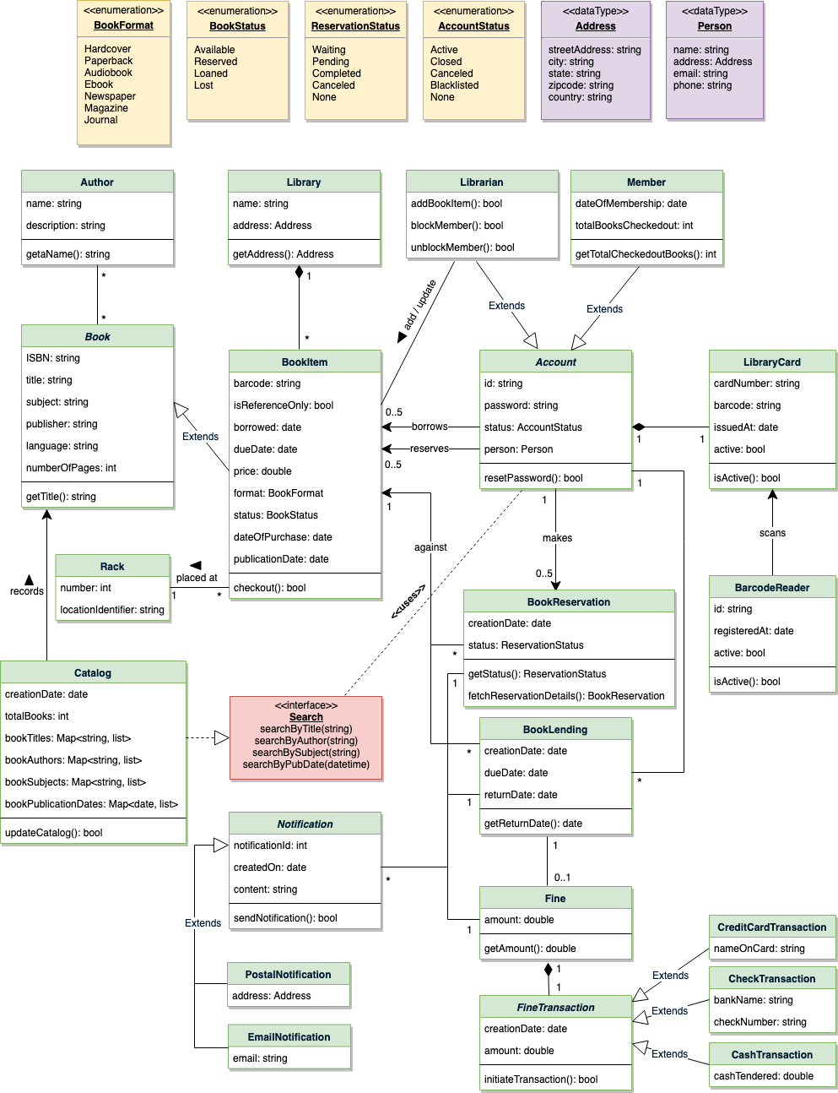

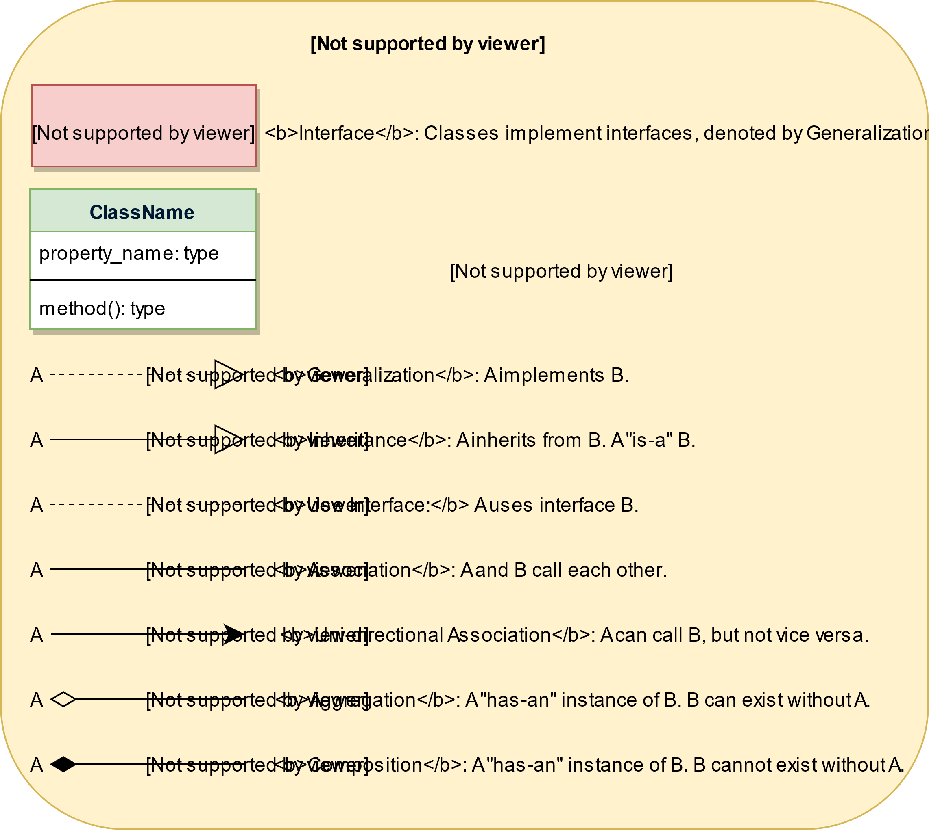

Class Diagram for Library Management System

### Activity Diagrams

**Check-out a book:** Any library member or librarian can perform this activity. Here are the set of steps to check-out a book:

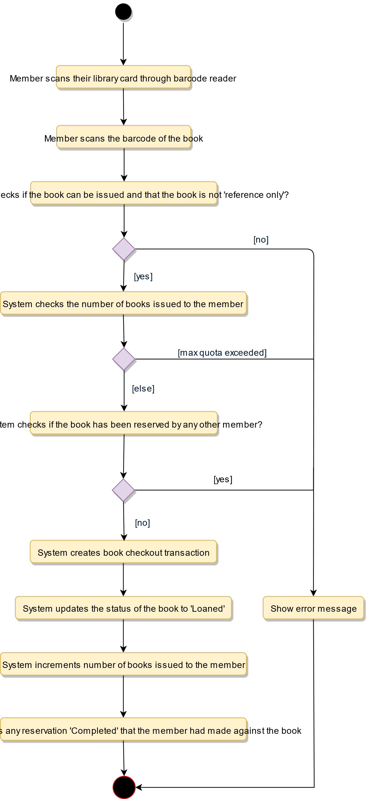

Activity Diagram for Library Management System Check-out Book

**Return a book:** Any library member or librarian can perform this activity. The system will collect fines from members if they return books after the due date. Here are the steps for returning a book:

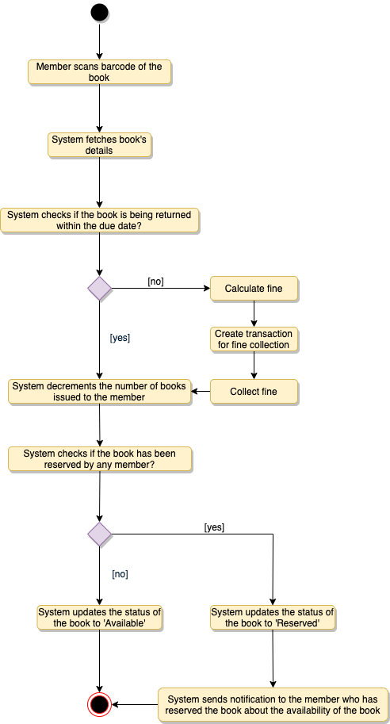

Activity Diagram for Library Management System Return Book

**Renew a book:** While renewing (re-issuing) a book, the system will check for fines and see if any other member has not reserved the same book, in that case the book item cannot be renewed. Here are the different steps for renewing a book:

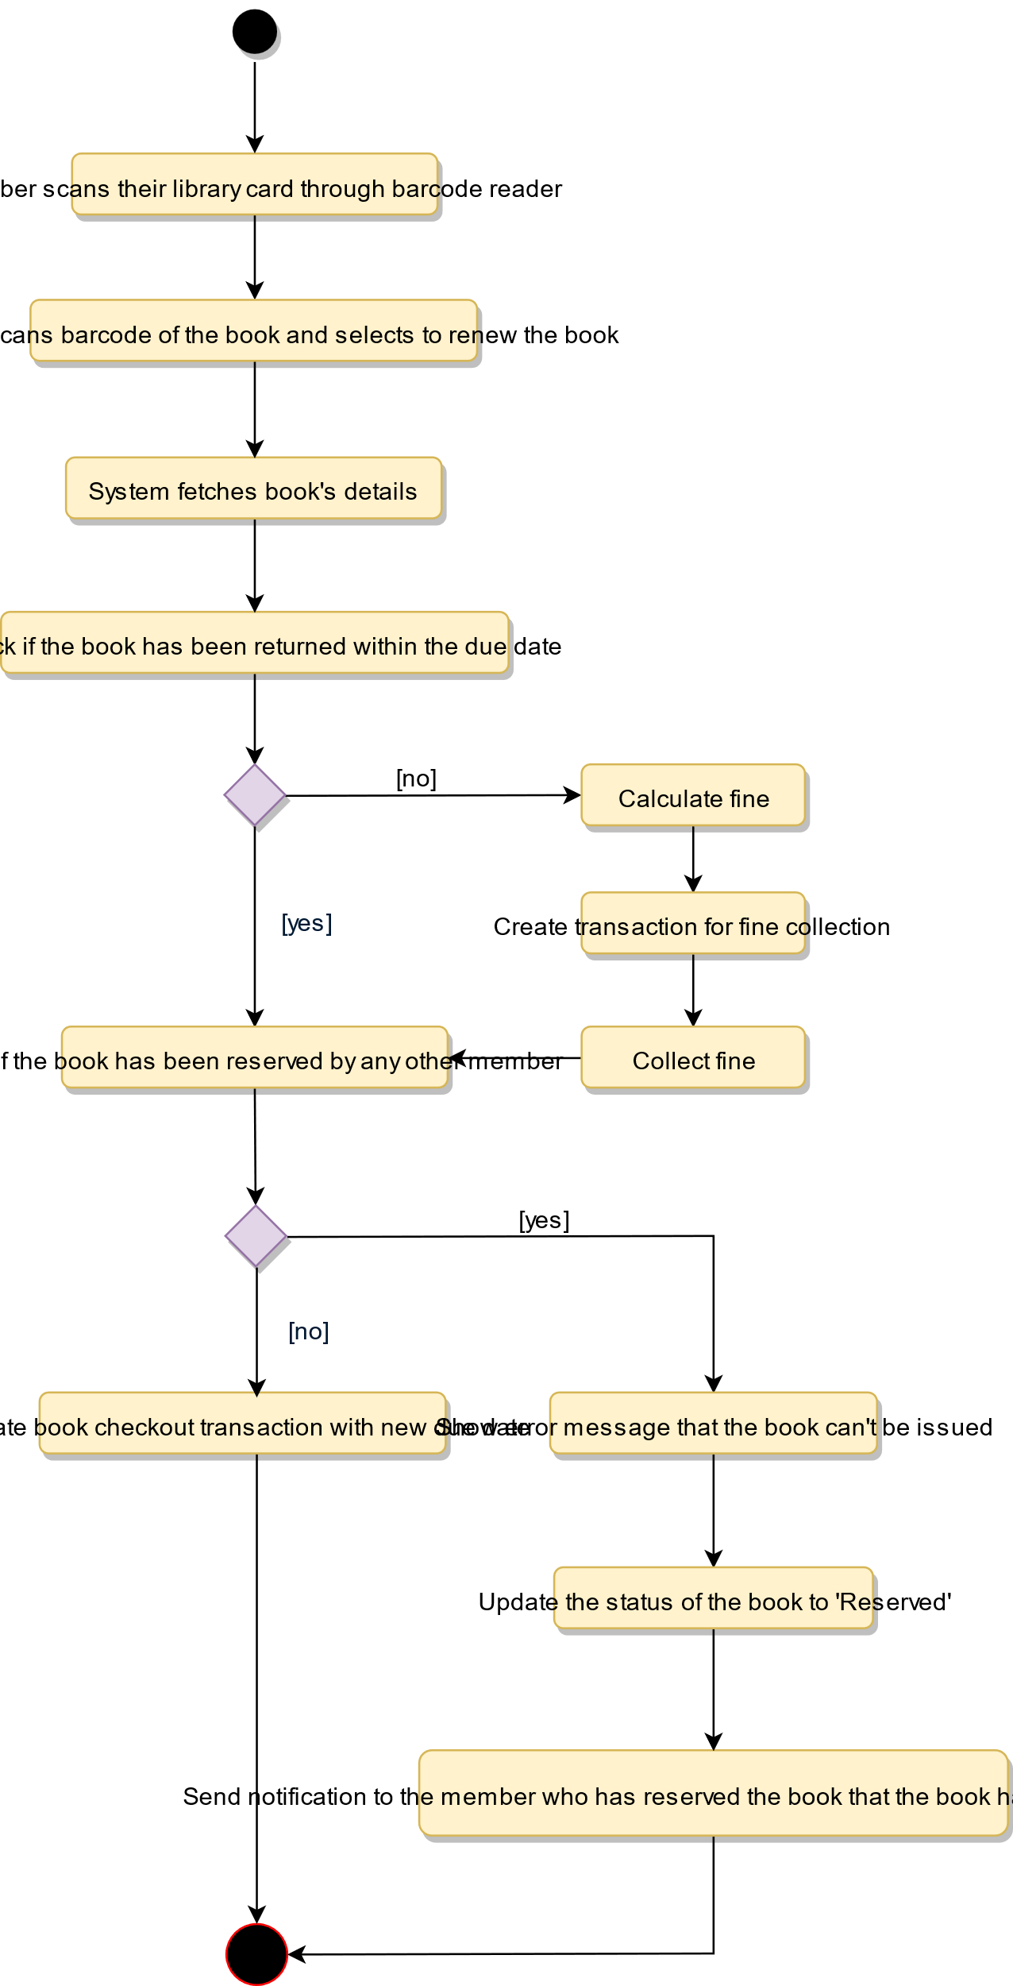

Activity Diagram for Library Management System Renew Book